2 Experiment Questions

Draw a labelled diagram of the apparatus used in this experiment

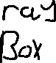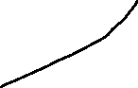

State the formula used to calculate the focal length

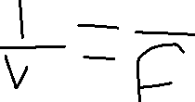

What instruments was used to take these measurements?

\*A ruler

Why did the student measure the approximate focal length at the start of the experiment?

\*The student measured the approximate focal length at the start of the experiment as a precaution.

The image distance is the less accurate measurement. Explain why.

\*The image distance is the less accurate measurement due to the subjective nature of perspective.

Draw a labelled diagram of the apparatus used in this experiment

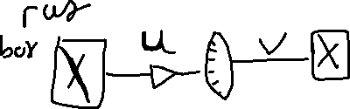

How did the observer know that the apparatus was correctly arranged to record the data?



\*The observer knew the apparatus was correctly arranged to record the data because they got a sharp image.

What measurements were taken? \*The measurements that were taken measured both U and V to find the focal length.



Calculate the value of the focal length f of the mirror.

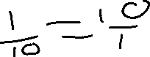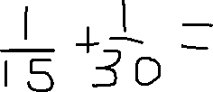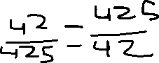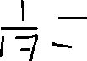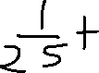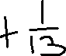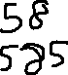

Why might it be an advantage to use a darkened room when carrying out this experiment?

\*It may be an advantage to use a darkened room so you can more accurately see the point of the sharp image.